Revision Examination Assessment Papers (REAP)
Semester 1 Examination 2012

Question/Answer Booklet
(This paper is not to be released to take home before 25/6/2012)

MATHEMATICS 3A
Section One:
Calculator-free

Name of Student: ______________________________________________

Time allowed for this section
Reading time before commencing work: 5 minutes
Working time for this section: 50 minutes

Materials required/recommended for this section
To be provided by the supervisor
This Question/Answer Booklet
Formula Sheet

To be provided by the student
Standard items: pens, pencils, pencil sharpener, eraser, correction fluid/tape, ruler,
highlighters
Special items: nil

Important note to students
No other items may be used in this section of the examination. It is your responsibility to ensure
that you do not have any unauthorised notes or other items in the examination room. If you have any unauthorised material with you, hand it to the supervisor before reading any further.

Structure of this paper
Section | Number of questions available | Number of questions to be answered | Working time  (minutes) | Marks available | Percentage of exam
Section One  Calculator-free | 6 | 6 | 50 | 50
Section Two  Calculator-assumed | 13 | 13 | 100 | 100
Total | 150 | 100

Instructions to students
1 Write your answers in the spaces provided in this Question/Answer Booklet. Spare pages are included at the end of this booklet. They can be used for planning your responses and/or as additional space if required to continue an answer. If you need to use the space to continue an answer, indicate in the original answer space where the answer is continued. i.e. give the page number. Fill in the number of the question(s) that you are continuing to answer at the top of the page.
2 Show all your working clearly. Your working should be in sufficient detail to allow your answers to be checked readily and for marks to be awarded for reasoning. Incorrect answers given without supporting reasoning cannot be allocated any marks. For any question or part question worth more than two marks, valid working or justification is required to receive full marks. If you repeat an answer to any question, ensure that you cancel the answer you do not wish to have marked.
3 It is recommended that you do not use pencil, except in diagrams.

Section One: Calculator-free (50 marks)
This section has six (6) questions. Answer all questions. Write your answers in the spaces provided.
Working time: 50 minutes
_________________________________________________________________________________
Question 1 (5 marks)
The marks in Mr Green’s Chemistry test are normally distributed. The mean is 100 and the standard deviation is 10.
(i) Jon’s mark is 115. What is his Z-score? (1)

(ii) Christopher has a Z-score of -2. What mark did he achieve in the test? (1)

(iii) What percentage of marks lies between 80 and 110? (3)
You may assume the following:
68% of marks have Z-scores between -1 and 1
95% of marks have Z-scores between -2 and 2
99.7% of marks have Z-scores between -3 and 3

Question 2 (8 marks)
(a) Jonathon used the ‘capture-recapture’ technique to estimate the number of yabbies living in a dam.
* He caught, tagged and released 20 yabbies.
* Later he caught 36 yabbies at random from the same dam.
* He found that 8 of these 36 yabbies had been tagged.
Estimate the total number of yabbies living in this dam. (3)

(b) Which of the following frequency histograms shows data that could be normally distributed? (1) (A) (B)
(C) (D)

Question 2 (continued)
(c) Radar checks were carried out on the speed driven by drivers on two days, on a stretch of Spencer Road. The results are tabled below.
Days | Mean | Standard deviation | Number of drivers
Wednesday | 60 | 10 | 100
Thursday | 70 | 5 | 100

On which day would you expect there to be more drivers exceeding 85km/h? Explain your answer. (2)

(d) The height of students in Mrs Smith’s class range from 150cm to 175cm. Their heights were measured one day and it was found that the mean height was 160cm. Two students were absent on the day when the measurement was taken. When the heights of the absent students were included in the data, the mean height did not change. What are the possible heights of the two absent students? (2)

Question 3 (7 marks)
LMN is drawn with LN = 3k units, MN = (4k+1) units and LM = (3k-1) units with k>0.
(i) Which side of LMN is the longest side? Justify your answer algebraically. (3)

(ii) If LMN is a right-angled triangle calculate the value(s) of k. (4)

Question 4 (10 marks)
(a) Sketch the graph of f(x)=2(x-1)². Show all intercepts. (2)
(b) Use the graph to find the value(s) of k for which
(i) (1)

(ii) (1)

(iii) (2)

(c) Indicate on the graph where you would read off the values for x if
4 = 2(x-1)² (1)
(d) Use your graph to solve 2x²- 4x + 6 = 0. Justify your answer. (3)

Question 5 (12 marks)
(a) State the domain and range (in set notation) for the function y = f(x) drawn below. (3)

(b) Given that g(x) = x²- x find
- g(-2) (1)

- g(2x+1) (2)

- x if g(x)=0 (2)

Question 5 (continued)
(c) Evaluate (2)

(d) Solve the equation, showing all working steps
(2)

Question 6 (8 Marks)
(a) The weight (W) in grams of individual Yoghurt Muesli Bars in a batch was measured to investigate their weight distribution.
- Using the normal distribution curve below with mean and standard deviation illustrate the meaning of (1)
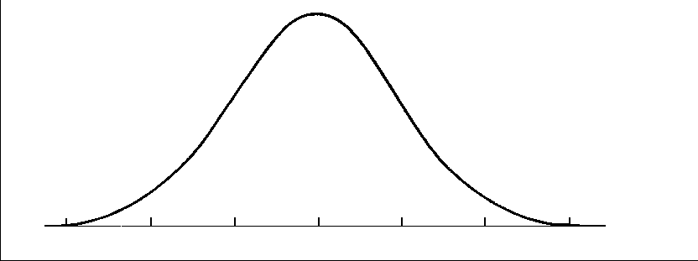
- Using the normal distribution curve below, illustrate the meaning of
(2)


- The following linear equations for the mean and the standard deviation were determined for the distribution of the weights of individual Yoghurt Muesli Bars:
Use the equations to find the mean weight and standard deviation of Yoghurt Muesli Bars. (2)

Question 6 (continued)
(b) The graph of y=f(x) has been plotted below

On the next 3 pairs of axes A, B, C are graphs of y=f(-x), f(x-1), -f(x) in some order. Say which corresponds to which graph. (3)
A B
C

Function | Graph
y = f(-x)
y = f(x -1 )
y = -f(x)

